Iain Farlow (s1903434)

A business & marketing plan for a newly formed company and the development of its hyper-casual mobile game.

Shield Breaker

Nameless Games

Contents

Executive Summary 2

Business of the company 2

Business Summary and history 2

Current situation of the company 2

Goal and Objectives 3

Shield Breaker 4

Gameplay 4

The Future of Shield Breaker 4

Market 5

Target Market Profile 5

Rules of purchase 5

Distribution 6

Competition 6

Direct Competitors 6

Indirect Competitors 6

Pricing 6

Marketing Stratagy Brief 7

Positioning 7

Sales Strategy and Tactics 7

Web Presence 7

Social Media 7

KeyWords & Slogans 8

Blog Posts 8

Update 1 – Market Research 8

Update 2 – Further Market Research 8

Update 3 – Basic Cutting Mechanic 9

Update 4 – Timed Cutting & Scaling 10

Update 5 – Music 11

Update 6 – Scoring & Minor Fixes 11

Update 7 – Game Loop & Gameplay Change 12

Update 8 – Menu 13

Update 9 – Save System 13

Update 10 – Finishing of Menu & Game 14

Update 11 – New Shields Added 15

Update 12 – Sounds & Level Music 15

References 15

Business & Marketing Plan 15

Shield Breaker 16

Links 17

Source Code 17

# Executive Summary

Shield Breaker is a hyper-causal game created by Nameless Games for Android. The game has two primary influences; Beat Saber and Piano Tiles utilising the 2D nature of Piano Tiles and rhythm-based cutting of Beat Saber. Shield Breaker is free to play but utilises advertisements to make the game profitable.

This document will outline the business and marketing plan for Shield Breaker. The main topics of this plan will regard; advisement of the game, the market the game will target, how the game will make revenue, and potential steps forward for the game.

# Business of the company

## Business Summary and history

As a newly formed company, Nameless Games will be releasing Shield Breaker as its first venture into the market. Due to this, marketing will be a key focus for the release of Shield Breaker, as it will aid to ensure a relevant place in the market is acquired. The aim of the company is to create hyper-casual games for release on the mobile market, primarily Android so ensuring a presence in the market is important due to the saturated nature of the market (MCV Staff 2015).

Despite the Nameless Games being new to the market, the lead programmer and director has been involved in making games for the last 4 years, both in and out of university. This history in the making of games allows for diverse and rounded experience in the production of Shield Breaker.

## Current situation of the company

In its current state Nameless Games only consists of a programmer in the team. This has led to the design elements of the game being neglected in the creation of the Shield Breaker. However, two options are available to allow the issues this presents to be avoided. One is to employ a dedicated designer to ensure the game, and future games, has consistent and quality artwork. The second option is to contract out the artwork to external creators. Either option will help to ensure that Nameless Games succeeds in the hyper-casual mobile games market. Design is important due to the need to provide users with feedback through their actions (Innovecs Games, 2020)

Despite this, the company is still in a position that can lead to success in the industry, because Shield Breaker can be completed to a high standard despite the lack of professionally designed content. This can be credited to the fact that

## Goal and Objectives

The primary short to medium-term goal of Nameless Games is to secure a foothold in the hyper-casual Mobile Market. This is not only due to the large size of the market, allowing for Nameless Games to be shown to a mass of people, but also the market’s growth rate. This means that once a share of the market has been established there will be potential for further success and growth, *see figure 1.*

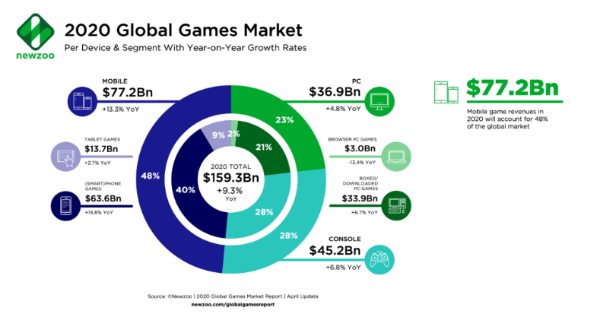

Figure : (Wijman 2020) 2020 Global Games Market

To keep a position in the industry it is imperative that Nameless Games ensures it provides a service with high customer satisfaction. This will not only mean releasing new games, but also updating current ones, helping resolve issues customers are having, and communicating with customers to ensure what they want is added to the game.

Not only will ensuring good customer satisfaction help Nameless Games in the Mobile Market, but also provides the opportunity for Nameless Games to venture into other markets. Customer satisfaction will help with this due to the fact that a pre-existing player base poses the opportunity for a wealth of customers for new releases, this is due to the fact that if customers find Nameless Games to produce reliable, quality content they are likely to follow them on social media, or steam / other stores.

# Shield Breaker

## Gameplay

Shield breaker has a very simple gameplay loop. Throughout the game, shields are spawned for the player cut based on the in-game music. These shields then fall into two circles (*see figure 2*), the outer of which shows when the player can cut the shield and an inner circle showing when they will gain multiplier for cutting the shield. This is a rather simple mechanic, however, there a very few games that focus on cutting in this manner.

Figure 2: Shield Breaker Level

During play the user will have to cut shields, as they enter shown regions, doing this in a shown direction. Failure to do this, either by swiping in the wrong direction or by failing to cut the shield will cause the multiplier in the game to drop to one. If the multiplier is already at one then the fail state is triggered, ending the level. If, however, the player makes it to the end of the song they are presented with the success screen. This will then show the stars earned by the player in that level. If the player has acquired more stars, than in their previous attempt at the level then the change instars with be added to their balance in the store.

## The Future of Shield Breaker

The key point that Nameless Games will focus on after the release of Shield Breaker is the acquisition of a designer. Since aesthetics play a key role when releasing games on any market. In Shield Breaker, this element was not focused on due to the lack of any design team. This means that acquiring such a team would benefit the company massively.

Not only this but doe the music-driven nature of Shield Breaker, Nameless Games aims to secure ties in the music industry. These ties can then be used to acquire music for Shield Breaker and potential future games. This connection to the music industry has the potential to be profitable for both Nameless Games and music creators. This is because if established Shield Breaker could be used by music creators as a way to advertise their music, also allowing Shield Breaker access to affordable music.

# Market

## Target Market Profile

The main platform Shield Breaker is going to be released for is Android. This is due to the vast number of users it will open Shield Breaker up to. This can primarily be put down to Samsung having such a large share of the market but can also be attributed to most other forms of handheld technology using Android, *see figure 3*. However, due to its large share of the market, IOS would also be a viable market, but due to its tailored design for simply Apple devices, it was decided to delay development for Apple until it is shown that Shield Breaker has the potential for success in the mobile market.

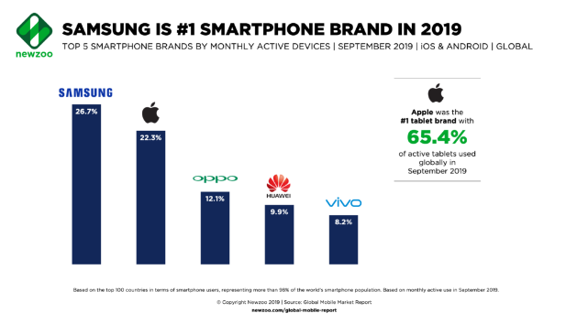

Figure 3: (Gu, 2019) Samsung is #1 Smartphone Brand in 2019

Much like targeting Shield Breaker to the Android platform, Shield Breaker will begin its release targeting the North American, and Western European markets. This is mainly due to the fact that Shield Breaker is to be created in English. It will, however, have versions of the game developed for other languages once Nameless games are well established in the market. This has been decided because of the massively increasing market in Asia and other areas of the world, *see figure 4.*

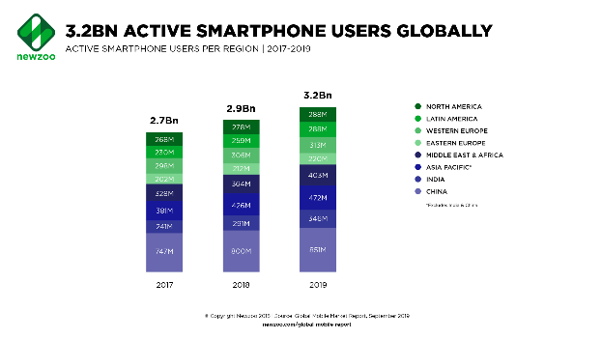

Figure 4: (Gu, 2019) Active Smartphone Users Globally

## Rules of purchase

Nameless games aim intends to releaser Shield Breaker completely free to play. This is due to this has become common practice in the games industry, therefore, if Shield Breaker was released with an initial cost, it is likely it would struggle to gain a player base. Being free to play, will allow for Shield Breaker to be used to penetrate the market and give Nameless Games apposition in the industry.

To make it profitable, Shield Breaker will utilise in-app purchases, as well as ads. The ads will come in three forms. The first is longer timed ads, this will be the most profitable of the ads and will run for 30 seconds (currently shown as 5 in the game for testing purposes). The next form of ad is a shot ad, this will simply mean an ad is shown to the user, for them to either investigate further or close. The third and final form of ad is a simple banner ad, this will appear at the bottom of the user’s screen. The other form monetisation will take is in the form of premium currency. This will allow for a more reliable, yet less used form of monetisation.

## Distribution

To allow for the game to be seen by a large number of users Nameless Games intends to contact hyper-casual game publishers, such as Voodoo or Ketchapp. Due to the large following these publishers have, it will allow for Nameless Games to release their first game to an already established player base. This will aid in avoiding the main issue new releases face, a lack of users.

# Competition

## Direct Competitors

In regards to direct competitors, Shield Breaker finds itself in a somewhat saturated market, this is due to the high amounts of rhythm-based games that are on the market. A selection of these being Piano Tiles, Beat Star, etc. These games are already established and therefore pose a significant threat, however, due to Shield Breaker’s focus on cutting as opposed to tapping or holding it has the possibility to hold its own share of the rhythm-based market. Furthermore, Shield Breaker intends to utilise lesser know artists for the music present in the game, this is intended to differentiate Shield Breaker based on emerging needs (Suarex and Kirtley, 2012).

## Indirect Competitors

The main issue when it comes to indirect competitors is the quality at which they have produced artwork. Games such as Helix Jump, Rise Up, Jelly Jump, etc. all have a very well-produced yet simple art style. This means that when compared to other hyper-casual games Shield Breaker has a very crude appearance. This is the reason why it will be imperative for Shield Breaker to secure a designer either in the form of a contractor or a dedicated designer.

## Pricing

Due to other music-based rhythm games using well-known songs Shield Breaker is presented with another way to establish a unique selling point in the market, by allowing lesser-known artists to use Shield Breaker as a form of advertisement for their game. As a result of this, it would be best for Shield breaker to only use the premium currency for shields. At present in Shield Breaker, it takes 100 coins to unlock a shield, this is designed to average around £0.99 but may vary from shield to shield. To ensure that songs from artists can be accessed by everyone, they will not be accessed through premium currency, instead, they will be accessed via ads and progression in the game.

# Marketing Stratagy Brief

## Positioning

The best category Shield Breaker falls into a hyper-casual mobile game. Casual games are very simple games that can be played in short bursts and played whenever the user feels like it. In addition to this Shield Breaker falls into the rhythm-based game category, due its use of music. This is a good position for Shield Breaker to hold in the industry both are well established yet with the help of a USP have the potential to allow for success.

## Sales Strategy and Tactics

As previously stated, the Nameless Games only consists of a programmer, therefore the graphics within Shield Breaker are extremely basic. However, according to Parker 2020 “you don’t need to worry too much about polishing the game’s world and UI; you just need to polish what matters for the ads”. This means that for Shield Breaker to have a successful campaign the focus needs to be the music, due to it being the primary element of the game. This means that the lack of a designer will hinder Shield Breaker’s release less than if graphics of the game were the primary element.

## Web Presence

To interact with journalists, other developers, publisher, and their users Nameless Games will create a website. This can then be used to release press kits, to best make use of media like magazines and news outlets. Alongside this, the website will hold dev longs for any game released by Nameless Games. This will not have a massive effect regarding the sales to the public but will attract individuals such as other game developers/ people interested in the industry, allowing, at the start of the release, for another method to create the start of player base.

## Social Media

The primary form of marketing Shield Breaker will utilise is that of social media, alongside ties to the industry and a publisher. This has the potential to allow for the game to build the start of a player base. From here, reviews from credible sources can be amassed and used in a larger-scale advertising campaign. From this point, however, advertising will cost, as the aim is to move beyond simply sharing on social media. Due to the way in which Facebook has designed its advertising system, Nameless games can dedicate how much it aims to spend per week on its advertising campaign. This means that based on resources available, and effectiveness, capital can be utilised for advertising. However, with the aid of a publisher, like Voodoo, advertising can be made more effective due to their previous knowledge in the area.

## KeyWords & Slogans

Slogan: Break them to a beat

Keywords: Music, slice, addicting, tune.

# Blog Posts

## Update 1 – Market Research

Upon beginning the market research for Nameless Game’s first release it was quickly found that a hyper-casual game for release on mobile would be a good first step for the company. This is due to the high amounts of potential customers that the market allows access to.

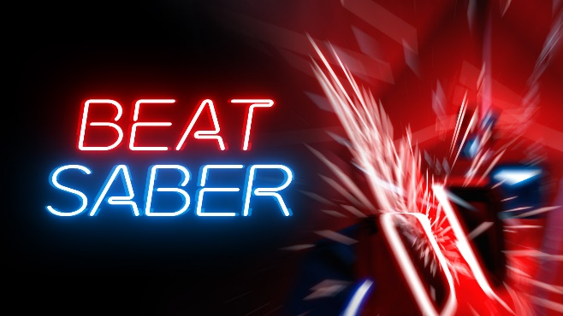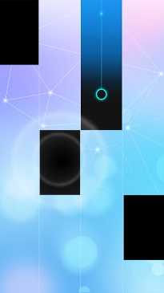

Regarding the game, it was decided that the best market to enter would be a pre-existing one with a gap in the market. For this, it was decided that a rhythm-based game would be a good market start in. However, due to the market being rather saturated a unique selling point was required. For this a swiping style game was found to be best, as there are few games currently on the market that use it as their primary mechanic, allowing for the potential for a player base to be established.

## Update 2 – Further Market Research

With most previous market research taking place on the Google Play store, it was ideal to also look at other markets, so it was decided to look on Steam for games relevant to Shield Breaker. This allowed for the market research to be broader than if just Google Play was used.

Furthermore, research into how to best monetise the game was conducted.was the best idea, as it allows for the largest player base to be accessed. Due to this, a premium currency & ads style of monetisation was decided upon. This is due to the allowing for the game to be monetised whilst also reaching the largest player base possible.

Also regarding accessing the largest player base possible research into advertising was conducted. This resulted in the conclusion that it was best to use social media to advertise Shield Breaker. This is due to the massive amounts of people this allows access to. Furthermore, until the game starts to receive users, social media can be used to advertise for free by simply creating a profile for the game. This profile can then be used to help to spread awareness of Shield Breaker throughout games production circles, helping create a foothold in the market.



## Update 3 – Basic Cutting Mechanic

The first step in the creation of Shield Breaker was the creation of the cutting mechanic. This key mechanic for the game so to ensure the development of the game is smooth it was decided to begin with the creation of one of the shields the player will have to cut. To do this Blender was utilised. Due to limited experience with Bender, it was decided that using simple shapes to create basic shields. However, due to the requirement for the shield to be cut the bisect tool was used allowing for the split shield to be created.

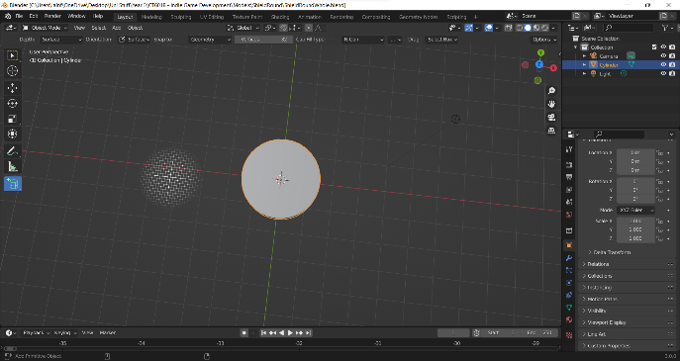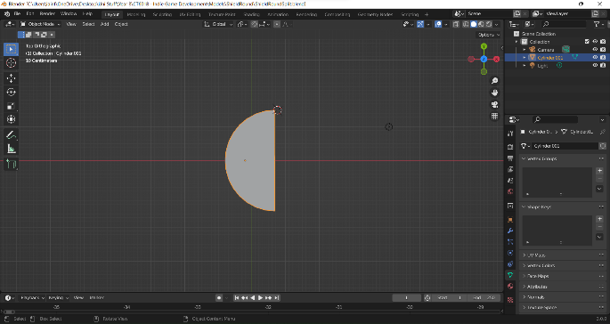

These objects were then used to create the cuttable shield and the broken shield that appear in the game. This allowed for the bases of the cutting mechanic to be implemented. These two states of the shield were then used alongside a “blade” to create the cutting mechanic used the in-game, by using a simple circle collider and trail renderer for the blade and analysing where the blade touches the circle to decide how it should cut.



## Update 4 – Timed Cutting & Scaling

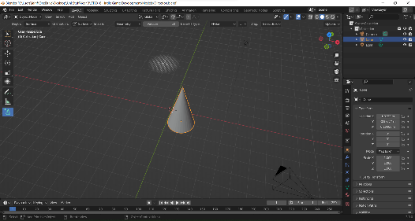To build upon the work shown in the previous update direction-specific slicing was added. This allowed for the base of the gameplay to be added. To do this a simple model was created that could allow for the direction required to cut the shield to be displayed.

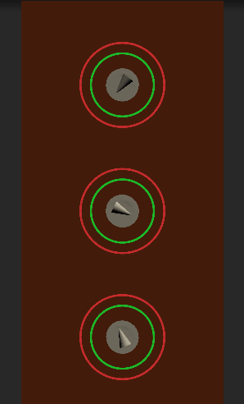In addition to this, it was decided to add a growing mechanic to the shields to indicate when they should be cut. To display this, two-line renderers were used to create wire circles around the spawn point of the shield, one for when cutting may begin and one for when the user has missed the shield.

These were then all combined, alongside a game manager to spawn the shield three times. This allowed for the game to be somewhat playable as the player must manage each of the shields, cutting them before they reach the outer circle.



## Update 5 – Music

Next, another part of the key mechanic was added, the implementation of the music-based spawning was added. To do this the spectrum data from the AudioListener was used. This allowed for the music being played to be analysed. With this data peaks in the music could be checked to detect beats in the music. Using two spawn points shields were created based on the beats of the music, one for higher beats and one for lower beats. This allows for the rhythm-based, cutting gameplay that is the key mechanic of the game. With the player having to manage two sets of shields that spawn based on the music playing in that level.



## Update 6 – Scoring & Minor Fixes

For this update the main change to the game is the functionality of the score and multiplier mechanic. In the previous update, the UI for this was added, however, in this one, they have been made to work. The score is conventionally done, with each shield cut giving the player 10 points, multiplied by the current multiplier. The multiplier, however, is increased with each shield cut, upping the multiplier by one each time, maxing out at 8. However, when the player misses a shield, the multiplier is reduced to one.



## Update 7 – Game Loop & Gameplay Change

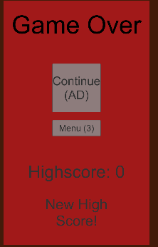The next stage of development was to add a full game loop. This mainly involved adding a simple game over screen that allowed the player to restart the level (go to the menu in the full game). As well as this, in the full game, the player will have the option to continue once per level. To do this they will have to watch an ad (ads being the main source of revenue planned for the game).

In addition to this, it was decided to change the main gameplay, changing from the shields growing in one place to falling from the top of the screen. This allowed for each shield to be shown, as opposed to stacked on top of each other. This made the game far more visually appealing as well as allowing the player to know the direction of the next shield. The spawning for this remained the same, using the music to spawn the shields.

However, the way the multiplier system worked was changed to allow the circles to be used differently. In this version of the game, the previously shown circles that dictated when the player can cut the shield have been used as different points for cutting. Now, the shields can only be cut once they have fallen into the outer circle. The inner circle is now used as a perfect/critical region. When the player cuts the shield in this region the multiplier is increased, when they simply cut in the outer region, they are simply rewarded with a just score.



## Update 8 – Menu

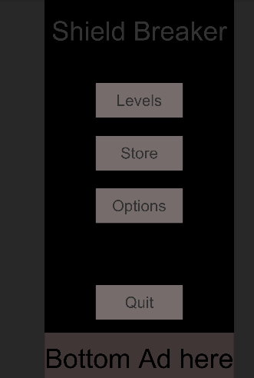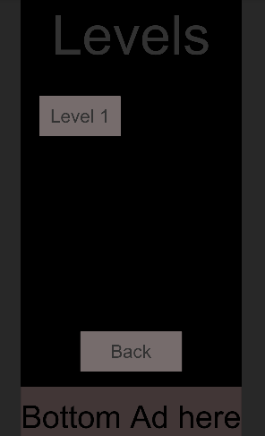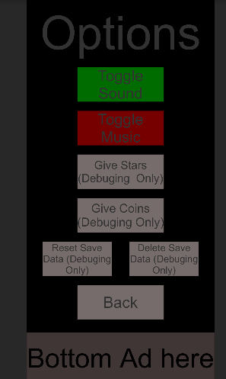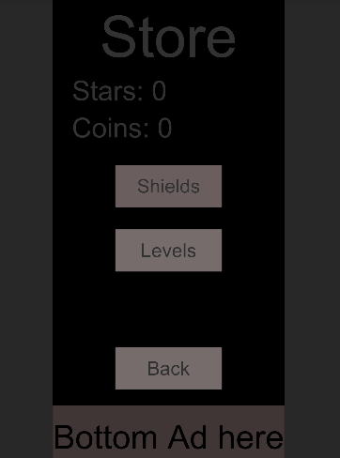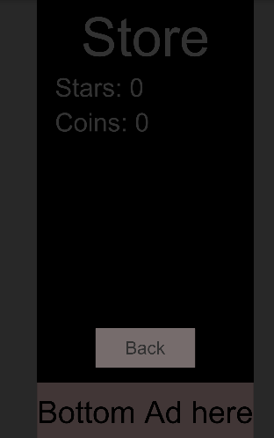

To progress further in development, the menu was created to allow for players to navigate between levels, change settings, buy shields, buy levels, and aid in debugging (give stars, coins, etc.). The menu was created using simple unity UI elements. Despite this, due to its simple and sleek design, the resulting menu has a nice, simple look, with the elements in it being of good size for a mobile game.

In addition to the menu, the functionality was added for the implementation of advertisements. In this, a handful of scenes were used to create dummy ads for the purpose of creating the vertical slice for the game. These were then added to the game. Appearing in the store, after each level, if the player uses a continue, and at the bottom of the screen as a banner type ad. These ads are not functional but are in to show how the game would be monetised.

## Update 9 – Save System

To make the menu and store functional a save system was required. This was done by creating and loading binary files. With this, a serializable class for the system data was created that contains all the data the game uses. In this, all the key variables of the game are stored, as well as the levels data, and the shield data. This allows for levels to be brought, data regarding them to be stored, and data regarding the purchase and equipping of various shields to be stored.

## Update 10 – Finishing of Menu & Game

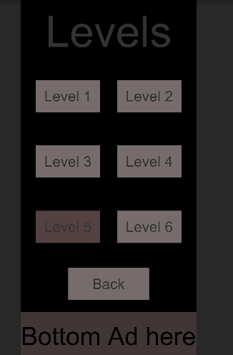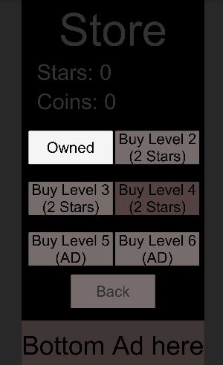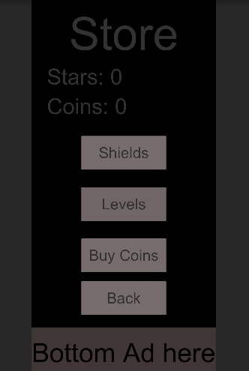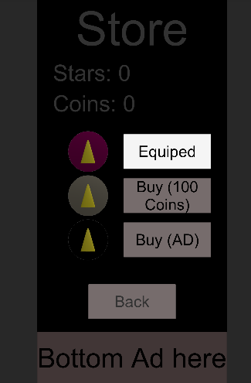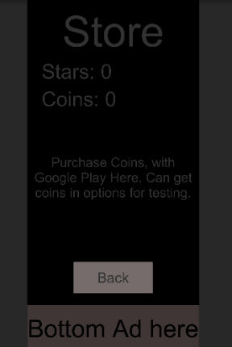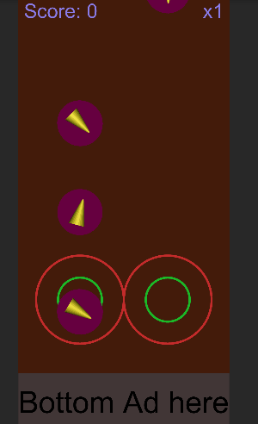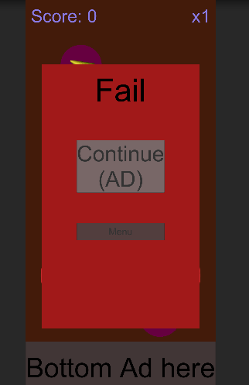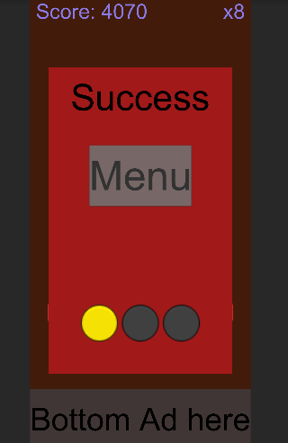

In order to progress to a more complete stage of development variety of levels were added. To company this the level store was populated with options to buy different levels using either stars (earned from levels) or by watching an advert. This will unlock the level, allowing the user to access to it. Not only this but a similar system was used to buy different shields (currently placeholders with various colours). These shields can then be equipped in the same menu. In the store section a screen to allow the purchasing of premium currently has been added. This has been added to demonstrate the ability to purchase premium currency with real money, in a full release this would like to the google play store to allow the user to securely make the purchase.

Furthermore, the game was adapted so that the shields move from the top of the screen at a more reasonable speed. This was found to be a massive improvement in comparison to the previous version of the game, increasing difficulty to a far more fun level. Alongside this a failure and success states were added, if the player fails, they will be given the option to either continue or go to the menu. If the player completes the level, they will be given an option to go to the menu, but will also be given the star rating, any new stars earned will be useable in the store.

## Update 11 – New Shields Added

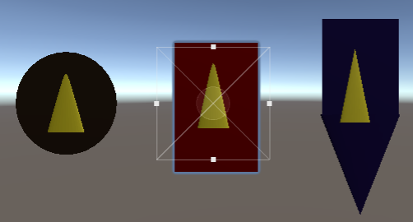Reaching close to the end of the development process it was decided that the creation of new shapes of the shield should be added. Now the player can choose from a selection of three shields. A round shield, a square shield, and a pointed shield. Due to limited design ability, these would be replaced if a contractor is available, or if a dedicated artist were accessible. If that were the case these shields would be changed to appear like a Viking round shield, a Roman scutum, or a Medieval kite shield. This is designed to give the user an incentive to spend money or watch ads. This would be upscaled if a designer were available.

## Update 12 – Sounds & Level Music

One of the final steps in finishing the development of Shield Breaker consisted of adding sounds and music to the game. This was done to ensure that there is the necessary feedback when the player correctly breaks a shield, critically breaks a shield, swipes wrong, or fails. This was a key element to the game as this audio feedback works alongside the music. Regarding the level music, a selection of music was found, that allowed for a varied soundtrack for each level. The variety of music will increase in updates of the game, giving further enticement to the user to purchase levels and spend on the game.



# References

## Business & Marketing Plan

Facebook, Advertising, [Online], Available At: [https://www.facebook.com/business/help/201828586525529?id=629338044106215&ref=fbb_budgeting#](https://www.facebook.com/business/help/201828586525529?id=629338044106215&ref=fbb_budgeting)

Suarez, F. F., and Kirtley J. (2012) “Dethroning an Established Platform”, MITSloan Management Review, p.38 Available At: <https://static1.squarespace.com/static/5654eb6ee4b0e19716ec5a92/t/56be91e29f72667c958ac5e6/1455329762959/2012_SMR_Dethroning+an+Established+Platform_Suarez-Kirtley.pdf>

Gu, T. (2019) ‘Newzoo’s Global Mobile Market Report: Insights into the World’s 3.2 Billion Smartphone Users, the Devices They Use & the Mobile Games They Play’, Newzoo, 17 September

Innocecs Games (2020) ‘FULL GUIDE TO MOBILE GAME DESIGN: THEORY AND BEST PRACTICES’, [Online], 7 August, Available At: <https://www.innovecsgames.com/blog/mobile-game-design/>

Ketchapp, [Online], Available At: https://www.ketchappgames.com/

MCV Staff (2015) ‘Understanding mobile games market saturation’, MCVUK, [Online], Available At: <https://www.mcvuk.com/development-news/understanding-mobile-games-market-saturation/>

Parker, J. (2020) ‘How To Market Test Your Hyper-Casual Mobile Games Successfully’, Kwalee, 4 August

Voodoo, [Online], Available At: <https://www.voodoo.io/>

Wijman, T. (2020) ‘The World’s 2.7 Billion Games Will Spend $159.3 Billion on Games in 2020; The Market Will Surpass $200 Billion by 2023’, Newzoo, 8 May

## Shield Breaker

Bertsz, 545455__bertsz__chiptuned-rock-music, [Online], Available At: <https://freesound.org/people/Bertsz/sounds/545455/> (Accessed: 30 December 2021)

Blender (Version 3.0.0). [Software]. (Last Accessed: 10 December 2021)

DaveJf, 584108__davejf__free-music, [Online], Available At: <https://freesound.org/people/DaveJf/sounds/584108/> (Accessed: 30 December 2021)

Deleted_user_6988258, 399821__deleted-user-6988258__awesome-background-melody-music, [Online], Available At: <https://freesound.org/people/deleted_user_6988258/sounds/399821/> (Accessed: 30 December 2021)

LiamG_SFX, 322163__liamg-sfx__shield-hit-10, [Online], Available At: <https://freesound.org/people/LiamG_SFX/sounds/322163/> (Accessed: 26 October 2021)

luffy, 3536__luffy__record-scratch, [Online], Available At: <https://freesound.org/people/luffy/sounds/3536/> (Accessed: 30 December 2021)

Migfus20, 559847__migfus20__guitar-music, [Online], Available At: <https://freesound.org/people/Migfus20/sounds/559847/> (Accessed: 30 December 2021)

PureDesignGirl, 538828__puredesigngirl__dramatic-music, [Online], Available At: <https://freesound.org/people/PureDesignGirl/sounds/538828/> (Accessed: 30 December 2021)

qubodup, 184422__qubodup__sword-slash-attack, [Online], Available At: <https://freesound.org/people/qubodup/sounds/184422/> (Accessed: 30 December 2021)

ShadyDave, 326553__shadydave__the-sonata-piano-loop, [Online], Available At: <https://freesound.org/people/ShadyDave/sounds/326553/> (Accessed: 30 December 2021)

Unity (Version 2019.4.13f1). [Software]. (Last Accessed: 19 January 2022)

# Links

## Source Code

<https://github.com/Iain2019/Indie-Game-Dev.git>

Unity game window should be in 1080 x 2240 (tested on Huawei p20 pro)